AN AI-ENABLED INTERVIEW SIMULATION AND ATS-COMPATIBLE RESUME SYSTEM FOR CAREER READINESS
A Project report (Stage-I) submitted in partial fulfillment of the Requirement for the Award of the Degree of

BACHELOR OF TECHNOLOGY
In
COMPUTER SCIENCE AND ENGINEERING
By
AKULA SANDEEP KUMAR | 22VD1A0548
CHEEKATI RAMYA | 22VD1A0542
MADDURI SREEJA | 22VD1A0556
MEDINI BHARATH | 22VD1A0508
KUMMARI NAVEEN | 22VD1A0530

Under the guidance of
Dr. B VISHNU VARDHAN
Senior Professor and Principal,

Department of Computer Science and Engineering, JNTUH University College of Engineering Manthani.
DEPARTMENT OF COMPUTER SCIENCE AND ENGINEERING JAWAHARLAL NEHRU TECHNOLOGICAL UNIVERSITY HYDERABAD
UNIVERSITY COLLEGE OF ENGINEERING MANTHANI
Pannur (Vill), Ramagiri (Mdl), Peddapally-505212, Telangana (India).
2025-2026

JAWAHARLAL NEHRU TECHNOLOGICAL UNIVERSITY HYDERABAD UNIVERSITY COLLEGE OF ENGINEERING MANTHANI
Pannur (Vill), Ramagiri (Mdl), Peddapally-505212, Telangana (India).
DEPARTMENT OF COMPUTER SCIENCE AND ENGINEERING

DECLARATION BY THE CANDIDATE
We,
AKULA SANDEEP KUMAR | 22VD1A0548
CHEEKATI RAMYA | 22VD1A0542
MADDURI SREEJA | 22VD1A0556
MEDINI BHARATH | 22VD1A0508
KUMMARI NAVEEN | 22VD1A0530
hereby declare that the project report entitled “AN AI-ENABLED INTERVIEW SIMULATION AND ATS-COMPATIBLE RESUME SYSTEM FOR CAREER READINESS” under the guidance of Dr. B VISHNU VARDHAN, Senior Professor and Principal, Department of Computer Science and Engineering, JNTUH University College of Engineering Manthani, submitted in partial fulfillment for the award of the Degree of Bachelor of Technology in Computer Science and Engineering.
This is a record of our Bonafide work, and the results embodied in this project report have not been reproduced or copied from any source. The results embodied in this project have not been submitted to any other University or Institute for the award of any degree.

AKULA SANDEEP KUMAR | 22VD1A0548
CHEEKATI RAMYA | 22VD1A0542
MADDURI SREEJA | 22VD1A0556
MEDINI BHARATH | 22VD1A0508
KUMMARI NAVEEN | 22VD1A0530

JAWAHARLAL NEHRU TECHNOLOGICAL UNIVERSITY HYDERABAD UNIVERSITY COLLEGE OF ENGINEERING MANTHANI
Pannur (Vill), Ramagiri (Mdl), Peddapally-505212, Telangana (India).

DEPARTMENT OF COMPUTER SCIENCE AND ENGINEERING
CERTIFICATE
This is to certify that the project report entitled “AN AI-ENABLED INTERVIEW SIMULATION AND ATS-COMPATIBLE RESUME SYSTEM FOR CAREER READINESS” is a Bonafide work carried out by

AKULA SANDEEP KUMAR | 22VD1A0548
CHEEKATI RAMYA | 22VD1A0542
MADDURI SREEJA | 22VD1A0556
MEDINI BHARATH | 22VD1A0508
KUMMARI NAVEEN | 22VD1A0530
in the partial fulfillment of the requirements for the award of the Degree of BACHELOR OF TECHNOLOGY in COMPUTER SCIENCE AND ENGINEERING, JAWAHARLAL NEHRU TECHNOLOGICAL UNIVERSITY HYDERABAD UNIVERSITY COLLEGE
OF ENGINEERING MANTHANI during the academic year 2025-2026.
The results of investigation enclosed in this report have been verified and found satisfactory. The results embodied in this project report have not been submitted to any other University or Institute for the award of any degree.

PROJECT GUIDE
Dr. B VISHNU VARDHAN
Senior Professor of CSE,
Principal of JNTUH UCEM
HEAD OF THE DEPARTMENT
EXTERNAL EXAMINER
DATE:

PROJECT REPORT (STAGE-I)

ACKNOWLEDGMENT

We feel honored and privileged to place our warm salutation to our Principal Dr. B VISHNU VARDHAN, Senior Professor of Computer Science and Engineering, JNTUH University College of Engineering Manthani who gave us the opportunity to have experience in engineering and profound technical knowledge.
We feel honored and privileged to place our warm salutation to our Vice-Principal Mr. M. UDAYKUMAR Associate Professor of Computer Science and Engineering, JNTUH University College of Engineering Manthani who gave us the opportunity to have experience in engineering and profound technical knowledge.
We extend our deep thanks to Dr. B Vishnu Vardhan for his constant encouragement,
valuable suggestions, and unwavering support throughout the completion of our project.
His guidance has been a continual source of motivation for us. We are extremely grateful to his valuable suggestions and unflinching cooperation throughout project work.
We are immensely obliged to other faculty members of Department of CSE for their kind co-operation.
We wish to convey our thanks to one and all those who have extended their helping hands directly and indirectly in completion of our project.
Last, but not least, our parents are also an important inspiration for us. So, with due regards, we express our gratitude to them.

AKULA SANDEEP KUMAR | 22VD1A0548
CHEEKATI RAMYA | 22VD1A0542
MADDURI SREEJA | 22VD1A0556
MEDINI BHARATH | 22VD1A0508
KUMMARI NAVEEN | 22VD1A0530

ABSTRACT
In recent years, job seekers have faced many challenges in the recruitment process. Many applicants are unable to perform well in interviews due to lack of preparation, low confidence, or unfamiliarity with role-specific questions. At the same time, a large number of resumes are rejected automatically by Applicant Tracking Systems (ATS) because of poor formatting, missing keywords, or improper structure.
Existing methods also have limitations. Mock interview tools usually provide the same set of questions to all candidates without considering their role or skills. They often lack real-time feedback, leaving candidates unsure about how to improve. Resume builders mostly focus on design or templates but fail to make resumes ATS-friendly. In short, existing methods are not personalized and are less effective in helping candidates succeed.
The proposed system is an AI-Enabled Interview Simulation and ATS-Compatible Resume System for complete career preparation. The Interview Module evaluates correctness, fluency, tone, and non-verbal cues, while the Resume Optimization Module analyses structure, formatting, and keyword relevance to determine ATS compliance. Using NLP models (BERT, Transformers), deep-learning based computer vision models (CNN, MediaPipe), and tailored ML approaches (Reinforcement Learning, Regression Models, Random Forest), the system provides adaptive evaluation with higher accuracy and flexibility than traditional approaches.
The system follows a multi-module architecture, where the user provides input such as resume, job description, and interview mode. The Resume Optimization Module extracts text using parsers or OCR and applies TF-IDF, BM25, and SBERT to check keyword relevance, semantic similarity, and ATS compliance, producing an ATS score with suggestions. The ATS-Friendly Resume Builder Module uses LaTeX-based templates to automatically format, structure, and generate ATS-compatible resumes. The Interview Simulation Module uses ASR to convert speech to text, applies NLP models for correctness, fluency, and tone, and uses computer vision for evaluating posture, gestures, and expressions. Each module generates its report independently, and if required, both reports can be merged into a single Final Evaluation Report.
The developed system combines AI-based interview simulation, ATS-resume scoring, and resume building within an integrated multi-module framework. By providing adaptive and personalized feedback, it improves interview performance, enhances resume quality, and increases the chances of selection and shortlisting.

Keywords: AI-Enabled Interview Simulation, ATS-Compatible Resume, Multi-Agent Architecture, Automatic Speech Recognition (ASR), Natural Language Processing (NLP), Transformer Models (BERT, SBERT), Deep Learning, Computer Vision, Convolutional Neural Networks (CNN), MediaPipe, Resume Parsing, Keyword Matching, Semantic Similarity, ATS Compliance, Candidate Evaluation, Interview Feedback.

TABLE OF CONTENTS

S.No. | CONTENT |  |  | PAGE No.
i | TITLE PAGE |  |  | i
ii | DECLARATION PAGE |  |  | ii
iii | CERTIFICATE |  |  | iii
iv | ACKNOWLEDGMENT |  |  | v
v | ABSTRACT |  |  | vi
vi | LIST OF FIGURES |  |  | x
1. | INTRODUCTION |  |  | 1
 | 1.1 | Interview & Resume Evaluation System
 | 1.2 | Problem Statement
 | 1.3 | Scope
 | 1.4 | Objective
 | 1.5 | Motive
2. | LITERATURE SURVEY |  |  | 5
 | 2.1 | Ai-Based Interview Simulation Systems
 | 2.2 | Ats-Based Resume Screening
 | 2.3 | Resume Builder and Optimization Systems
 | 2.4 | Combined Career Readiness Systems
 | 2.5 | Summary of Literature Survey
3. | SYSTEM ANALYSIS |  |  | 9
 | 3.1 | Existing System
 |  | 3.1.1 | Limitations of Existing System
 | 3.2 | Proposed System
 | 3.3 | Technologies Used
 |  | 3.3.1 | Advantages of the Proposed System
 | 3.4 | Feasibility Study
 |  | 3.4.1 | Technical Feasibility
 |  | 3.4.2 | Operational Feasibility
 |  | 3.4.3 | Economic Feasibility
 |  | 3.4.4 | Schedule Feasibility
 |  | 3.4.5 | Legal and Ethical Feasibility
4. | SYSTEM REQUIREMENTS SPECIFICATION |  |  | 13
 | 4.1 | Non-Functional Requirements
 |  | 4.1.1 | Usability:
 |  | 4.1.2 | Reliability:
 |  | 4.1.3 | Performance:
 |  | 4.1.4 | Supportability:
 |  | 4.1.5 | Implementation:
 |  | 4.1.6 | Interface:
 |  | 4.1.7 | Legal:
 | 4.2 | Hardware Requirements
 | 4.3 | Software Requirements
5. | SYSTEM DESIGN |  |  | 17
 | 5.1 | High-Level Design
 |  | 5.1.1 | Ats Resume Scoring Module:
 |  | 5.1.2 | Interview Simulation and Evaluation Module:
 |  | 5.1.3 | Ats-Friendly Resume Builder Module:
 |  | 5.1.4 | Dataset Used:
 | 5.2 | Low-Level Design
 |  | 5.2.1 | Introduction To UML
 |  | 5.2.2 | Use Case Diagram
 |  | 5.2.3 | Sequence Diagram
 |  | 5.2.4 | Activity Diagram
 |  | 5.2.5 | Class Diagram
 |  | 5.2.6 | System Architecture
6. | CONCLUSION |  |  | 25
7. | BIBLIOGRAPHY |  |  | 27

 | LIST OF FIGURES
FIGURE NO | FIGURE NAME | PAGE NO
Fig 5.2.2.1 | Use Case Diagram | 21
Fig 5.2.3.1 | Sequence Diagram | 22
Fig 5.2.4.1 | Activity Diagram | 23
Fig 5.2.5.1 | Class Diagram | 23
Fig 5.2.6.1 | System Architecture | 24

INTRODUCTION

INTRODUCTION
The recruitment and hiring landscape is undergoing a rapid shift due to the integration of Artificial Intelligence and automation. Organizations increasingly utilize Applicant Tracking Systems (ATS), automated resume screening, and virtual assessments to select candidates. Although this transition enhances efficiency for employers, it creates new difficulties for job seekers who are unfamiliar with ATS ranking, professional resume standards, and evaluation criteria for interviews. As a result, many candidates are rejected in the early screening stages despite having suitable skills for the role.
The recruitment and hiring landscape is undergoing a rapid shift due to the integration of Artificial Intelligence and automation. Organizations increasingly utilize Applicant Tracking Systems (ATS), automated resume screening, and virtual assessments to select candidates. Although this transition enhances efficiency for employers, it creates new difficulties for job seekers who are unfamiliar with ATS ranking, professional resume standards, and evaluation criteria for interviews. As a result, many candidates are rejected in the early screening stages despite having suitable skills for the role.

INTERVIEW & RESUME EVALUATION SYSTEM
A modern interview and resume readiness system combines Artificial Intelligence, NLP, computer vision, and ATS-based evaluation techniques to support job seekers in preparing for hiring processes. Such systems simulate real-world interview environments and evaluate resumes based on corporate recruitment standards.
The proposed system integrates three major components:
- AI-Enabled Interview Simulation – conducts mock interviews using voice/video inputs and evaluates correctness, tone, speaking clarity, and non-verbal cues.
- ATS Resume Scoring – analyses structure, keywords, formatting, and semantic relevance between resume and job description.
- ATS-Friendly Resume Builder – helps generate or modify resumes so that they meet ATS requirements and improve selection chances.
By combining interview performance assessment and resume optimization into a single framework, the system acts as a complete career-readiness solution.

PROBLEM STATEMENT
In current recruitment processes, most companies use Applicant Tracking Systems (ATS) and AI-based filters to shortlist candidates. Due to this:
- Resumes are rejected before reaching HR due to missing keywords and poor formatting.
- Candidates lack access to platforms that simulate interview difficulty or provide structured feedback.
- Existing tools focus on either mock interviews or resume building, but not both together.
- There is limited guidance on improving confidence, communication, and resume relevance.
Thus, a major gap exists in providing a unified solution capable of evaluating the resume for ATS compliance and conducting intelligent interview simulations with actionable feedback.
There is a need for a system that can:
- Assess resumes using ATS rules,
- Simulate real interview environments,
- Provide performance scoring and improvement reports,
- Help candidates prepare effectively for recruitment.

SCOPE
The scope of the project is to develop a centralized AI-driven platform that provides comprehensive career preparation through:
AI Interview Module
- Voice/video interview simulation
- Question evaluation based on correctness, fluency, tone, and confidence
- Non-verbal cue analysis (facial expressions, posture)

ATS Resume Evaluation Module
- Resume text extraction and parsing
- Keyword density analysis
- Semantic matching with job description
- ATS score calculation
ATS-Friendly Resume Builder
- Resume improvement suggestions
- Keyword recommendations
- Format and structure optimization
- Resume generation in ATS-compatible templates
The system is targeted at job seekers, fresh graduates, placement cells, and professional training centers.

OBJECTIVE
The main objective is to build an intelligent platform that improves employability by evaluating and optimizing both interview performance and resumes.
The specific objectives include:
- To simulate mock interviews using real-time audio/video input
- To analyse candidate communication, correctness, and confidence
- To extract resume text and compare it with job descriptions
- To evaluate resumes using ATS standards
- To generate ATS-friendly resumes
- To create personalized feedback reports that help improve hiring chances

MOTIVE
The motivation for this project is based on real challenges in modern recruitment environments. Many qualified candidates face rejection due to:
- ATS-incompatible resumes,
- Lack of interview practice,
- Lack of personalized feedback,
- Limited awareness of interview evaluation criteria.
Hiring is becoming more AI-driven, but preparation tools are not equally advanced. This project aims to:
- Increase candidates’ success rate in recruitment,
- Reduce failures due to ATS screening,
- Provide a fair and scalable interview preparation platform,
- Support professional growth and career readiness using AI.
The ultimate motive is to develop a system that empowers job seekers and prepares them for real hiring processes in a practical, intelligent, and efficient manner.

LITERATURE SURVEY

LITERATURE SURVEY
Recent research trends in recruitment show a major shift towards AI‐based candidate evaluation. Techniques such as Natural Language Processing (NLP), Machine Learning, Computer Vision, and Applicant Tracking Systems (ATS) have been applied to resume analysis and automated interview evaluation. Modern approaches also utilize deep learning and semantic matching for predicting job-candidate compatibility.

AI-BASED INTERVIEW SIMULATION SYSTEMS
Several studies propose the usage of NLP and Machine Learning models for evaluating candidate responses in mock interviews.
Commonly used technologies include:
- Transformer-based NLP models such as BERT and SBERT for semantic evaluation of text answers.
- Automatic Speech Recognition (ASR) for converting voice responses into text.
- Sentiment analysis and speech fluency analysis for evaluating communication clarity.
- Deep Learning and Computer Vision models such as CNN and MediaPipe for analysing facial expressions, gaze, head movement, and confidence.
Limitations in existing works:
  - Do not analyse non-verbal cues accurately
  - Provide no real-time feedback
  - Limited adaptation for different job roles

ATS-BASED RESUME SCREENING
Research in resume evaluation emphasizes the importance of ATS algorithms for filtering resumes. Several studies highlight the effectiveness of keyword extraction and semantic matching.
Technologies used in existing research:
      - TF-IDF (Term Frequency–Inverse Document Frequency) for text feature extraction.
      - BM25 ranking algorithm for job description matching.
      - SBERT for sentence similarity.
      - OCR and parsing tools for extracting information from uploaded resumes.

Limitations in existing systems:
- Focus mainly on formatting rules
- Cannot predict ATS score accurately
- Lack resume improvement suggestions

RESUME BUILDER AND OPTIMIZATION SYSTEMS
Various systems have been implemented for resume generation, but most focus on aesthetics rather than ATS scoring.
Modern approaches recommend technologies such as:
- Keyword recommendation based on NLP models
- Structure validation based on ATS standards
- Machine Learning for template selection and ranking
Identified limitations:
- Cannot analyse semantic similarity with job descriptions
- No feedback mechanism for improving resumes
- Lack of integrated resume + interview platform

COMBINED CAREER READINESS SYSTEMS
Recent studies show attempts to combine multiple modules, but they still lack integration.
The comparison below summarizes the gap:
Feature | Existing Systems | Proposed System
AI Interview Simulation | ✔ | ✔
ATS Resume Scoring | ✖ | ✔
Resume Builder | ✔ | ✔
Deep Learning CV Models | ✖ | ✔
TF-IDF / BM25 | Partial | ✔
NLP Models (BERT, SBERT) | Partial | ✔
OCR / Parsing | ✖ | ✔

Key Gap:
No research provides a complete system integrating:
- AI interview evaluation,
- ATS scoring,
- ATS-friendly resume building,
- and multi-modal analysis.

SUMMARY OF LITERATURE SURVEY
The reviewed literature highlights continuous improvements in AI-based recruitment evaluation using:
- Transformer models (BERT, SBERT) for text analysis,
- TF-IDF and BM25 for keyword and ranking evaluation,
- CNN and MediaPipe for non-verbal cue detection,
- OCR and Resume Parsers for structured document analysis,
- Speech-to-Text ASR for interview assessment.
However, existing tools either focus only on resume building or only on mock interviews. None of them combine these three features into a single platform. The proposed system fills this gap by providing:
- ATS-compatible resume building,
- ATS scoring,
- and AI-driven interview simulation.

SYSTEM ANALYSIS

SYSTEM ANALYSIS
The system analysis chapter examines the existing approaches in the domain of career readiness tools and highlights the challenges, limitations, and opportunities for improvement. A detailed analysis of the proposed system is also presented, along with a discussion on feasibility from technical, operational, and economic perspectives.

EXISTING SYSTEM
Several existing solutions in the recruitment and interview preparation domain are available in the form of mock interview applications, resume builders, and Applicant Tracking Systems (ATS). These systems provide partial assistance to job seekers but lack comprehensive support throughout the recruitment process.
Existing mock interview platforms generally rely on predefined question sets and provide only textual or static feedback. They do not assess the quality of verbal communication, fluency, tone, or non-verbal behaviour such as facial expressions and posture. Similarly, resume-building tools focus mainly on template formatting and visual design, while ignoring ATS compatibility standards such as semantic relevance, keyword matching, structured layout, and machine-readability.
Commercial ATS platforms are primarily intended for employers to filter a large number of resumes based on structured queries, keyword presence, and ranking algorithms. However, these systems do not assist candidates in improving their resumes or understanding the cause of rejection. As a result, job seekers receive limited feedback and have fewer opportunities to self-evaluate.
Thus, existing systems function in isolation and do not provide integrated solutions that combine interview simulation, ATS-based resume evaluation, and resume optimization.

LIMITATIONS OF EXISTING SYSTEM
The major limitations of the current systems are as follows:
- Lack of integrated platforms supporting both resume and interview evaluation.
- Resume builders focus on formatting rather than ATS standards.
- Interview tools do not perform multi-modal analysis of candidate performance.
- ATS systems do not provide improvement suggestions to candidates.
- Absence of personalized feedback and performance reports.
- No mechanism for comparing resumes with job descriptions.
- Limited accuracy in evaluating communication and non-verbal parameters.
- No unified approach to end-to-end career readiness.

PROPOSED SYSTEM
The proposed system aims to overcome the limitations of the existing tools by providing an integrated career readiness platform that combines three core functionalities:
- AI-enabled Interview Simulation
- ATS-based Resume Scoring
- ATS-Compatible Resume Builder
The system evaluates interview performance using speech recognition, Natural Language Processing (NLP), and Computer Vision. It assesses candidate communication skills based on correctness, tone, fluency, clarity, and non-verbal behaviour. Concurrently, the resume scoring module evaluates a resume using ATS guidelines, semantic similarity, keyword density, and job description compatibility.
The system further guides the user to develop an ATS-compliant resume by recommending format structures, required keywords, and improving overall document quality.

TECHNOLOGIES USED
The proposed platform incorporates the following technologies:
- NLP Models: BERT, SBERT, Transformers for semantic analysis
- ATS Ranking Algorithms: TF-IDF, BM25 for keyword and similarity evaluation
- Machine Learning Models: Random Forest, Regression Models for scoring and prediction
- Computer Vision: MediaPipe, CNN for facial expression and posture analysis
- ASR and OCR: For speech-to-text processing and resume parsing
These technologies enable the system to perform intelligent evaluation and generate accurate results.

ADVANTAGES OF THE PROPOSED SYSTEM
The proposed system offers several advantages over existing approaches:
- Provides a unified platform for resume evaluation and interview simulation.
- Increases resume acceptance by ensuring ATS compliance.
- Offers real-time and personalized feedback for performance improvement.
- Enhances confidence and communication skills of job seekers.
- Scalable and suitable for various job roles and industries.
- Supports automated analysis for both verbal and non-verbal cues.

FEASIBILITY STUDY
A feasibility study was conducted to determine the viability of the system. The system was evaluated based on the following criteria:
Five key considerations involved in the feasibility analysis are

TECHNICAL FEASIBILITY:
The system utilizes proven and widely adopted technologies such as NLP frameworks, resume parsing tools, ATS ranking algorithms, speech recognition, and Computer Vision. These technologies ensure reliable implementation, scalability, and performance, making the system technically feasible.

OPERATIONAL FEASIBILITY:
The platform is user-friendly and does not require advanced technical expertise. The workflow is intuitive and supports automated processes such as resume uploading, interview recording, and feedback generation. Regular maintenance and updates can be performed without operational complexity.

ECONOMIC FEASIBILITY:
The development and deployment of the system are economically viable due to the availability of open-source tools and frameworks. The implementation cost is minimal, and the system provides significant value in terms of improved candidate outcomes and enhanced employability.

SCHEDULE FEASIBILITY:
The development process can be divided into well-defined phases, including module development, testing, and deployment. Each module can be implemented incrementally, allowing efficient time management and iterative improvement.

LEGAL AND ETHICAL FEASIBILITY:
The system adheres to data privacy and security standards by ensuring secure handling of user resumes and interview data. Ethical AI practices and transparent processing are maintained to avoid discriminatory evaluation and bias.

SYSTEM REQUIREMENTS SPECIFICATION

SYSTEM REQUIREMENTS SPECIFICATION
A Software Requirements Specification (SRS) plays a critical role in defining the functional and operational capabilities of a system. It specifies the requirements in a structured manner such that the implementation process is smooth and results in a reliable product. The SRS document clearly describes all system requirements so that the design and development phases can proceed without ambiguity. The specification can be represented using a combination of textual descriptions, tables, and diagrams. The representation should be consistent and modifiable.

NON-FUNCTIONAL REQUIREMENTS

USABILITY:
The system provides a user-friendly interface that enables users to upload resumes, attend mock interviews, and view evaluation reports without technical expertise. The usability is ensured through simple navigation, interactive feedback, and minimal data entry.

RELIABILITY:
The system is designed to perform accurate processing of resumes and interview responses under different usage conditions. It ensures consistent performance in ATS scoring, keyword analysis, and voice/video processing.

PERFORMANCE:
The system analyzes resumes, calculates ATS score, and processes interview responses within acceptable time limits. The evaluation modules achieve results with high accuracy based on pre-trained models and machine learning algorithm.

SUPPORTABILITY:
The system architecture is modular and scalable, enabling future enhancements such as support for additional job roles, multiple resume formats, and improved evaluation models.

IMPLEMENTATION:
The implementation involves integrating NLP, ML, and ATS-based evaluation algorithms. The platform enables resume parsing, scoring, interview simulation, and feedback generation with minimal resource consumption.

INTERFACE:
The interface supports user interaction through:
- Resume upload modules,
- Job description input,
- Interview voice/video input processing,
- Result and feedback dashboards.
APIs and input/output services ensure communication between modules such as ATS scoring, AI interview analysis, and resume formatting.

LEGAL:
The system ensures secure processing of resumes, interview recordings, and personal data. It follows privacy policies and terms of usage. No proprietary data is stored or shared without consent.

HARDWARE REQUIREMENTS
Component | Minimum Specification | Recommended Specification
Processor | Intel i3 / Ryzen 3 | Intel i5/i7 / Ryzen 5/7
RAM | 8 GB | 16 GB+
Storage | 256 GB SSD | 512 GB SSD
GPU | Integrated GPU | NVIDIA RTX 3060/3080
Webcam | Basic HD camera | Full HD (1080p)
Microphone | Standard mic | Noise-cancelling mic

SOFTWARE REQUIREMENTS
    - Operating System: Windows 10/11 or Linux
    - Programming Language: Python 3.10+, JavaScript/TypeScript (Frontend: Next.js/React)
    - Web Browser: Latest version of Chrome / Microsoft Edge
    - Frameworks / Libraries:
- Flask/Django
- BERT / SBERT
- TF-IDF, BM25 implementations
- MediaPipe & OpenCV
- OCR libraries
- Whisper / ASR libraries
- Scikit-Learn
- Development Platform: Visual Studio Code or PyCharm, Postman (API testing) and GitHub (Version Control)
- PYTHON
Python is selected as the primary development language due to its simplicity, extensive library support, and strong integration with machine learning, NLP, and AI modules. Python supports modular development and rapid deployment, and includes numerous open-source packages for ATS evaluation, resume parsing, and interview simulation.
- VISUAL STUDIO CODE
Visual Studio Code is used as the IDE for development. It supports:
- Python execution,
- Package and environment setup,
- Version control integration,
- Front-end + back-end development.

SYSTEM DESIGN

SYSTEM DESIGN
The system design phase is one of the most crucial stages of software development, as it determines the structural and functional organization of the proposed system. System design transforms the system requirements into a detailed blueprint that guides development, implementation, and testing. It embodies both the conceptual architecture and technical specifications that govern the behaviour of the software components. The design process defines not only how the components of the system are structured, but also how they interact in order to accomplish the intended objectives.
The objective of system design is to develop a robust architecture capable of delivering the required functionalities including ATS resume evaluation, interview simulation, and resume optimization. High-level and low-level design techniques are employed to ensure modularity, scalability, security, and maintainability. Moreover, system design bridges the gap between requirement analysis and implementation by providing clarity regarding data flow, module interactions, and internal data representation.
A sound system design ensures that the final product aligns with user expectations, supports future enhancements, and conforms to quality parameters such as usability, performance, and reliability. If the design is not carefully executed, further development stages may be inefficient, error-prone, or costly to modify. Hence, design plays a pivotal role in determining system success.

HIGH-LEVEL DESIGN
The high-level design of the proposed system defines the major architectural components and the interaction between them. The system integrates three major modules that function collaboratively to provide end-to-end career readiness support:

ATS RESUME SCORING MODULE:
This module performs resume evaluation using Natural Language Processing and Machine Learning techniques. Key processing stages include text extraction, keyword matching, format analysis, semantic comparison with job descriptions, and score computation. Advanced ranking algorithms such as BM25 and TF-IDF ensure accurate evaluation of resume content based on ATS criteria. The output of this module is an ATS score along with improvement suggestions.

INTERVIEW SIMULATION AND EVALUATION MODULE:
The interview simulation module is responsible for assessing the candidate’s spoken communication and interview readiness. Automatic Speech Recognition tools are used to convert audio responses into text. NLP techniques are applied to evaluate correctness, tone, fluency, and structure of the answer. Additionally, models like MediaPipe or CNN may be utilized for non-verbal analysis such as expression and attentiveness.

ATS-FRIENDLY RESUME BUILDER MODULE:
This module implements an automated resume generation system using LaTeX-based templates and formatting rules. It assists the user in creating a resume that conforms to ATS readability and structure guidelines. Based on the ATS score and feedback, the builder recommends changes and reorganizes resume elements into standardized sections, ensuring compatibility with ATS software used by recruiters.
All three modules interact through the application interface and data-processing pipeline to produce consolidated feedback for the user.

DATASET USED:
The system requires suitable data sources for resume analysis, NLP-based comparison, and interview question selection. Pre-trained models and publicly available datasets are employed to ensure reliability and accuracy. The following datasets and corpora were utilized:
- BERT and SBERT Models: for semantic similarity and textual evaluation.
- TF-IDF and BM25 corpora: for keyword-based resume evaluation.
- Resume and job description datasets: for extracting common hiring patterns.
- Interview datasets and question banks: used for generating mock interview sessions.
- OCR datasets: facilitate parsing PDF and document-based resumes.
Purpose | Dataset Examples
Resume parsing | Kaggle Resume Dataset
Job description matching | Indeed / LinkedIn scraped datasets
Interview QA | Public technical/non-technical QA sets
Speech recognition | LibriSpeech, CommonVoice
Facial emotion analysis | FER-2013, AffectNet

These datasets collectively support the intelligent scoring and evaluation processes essential for the system

LOW-LEVEL DESIGN
Low-level design provides a detailed view of internal system operations, data flows, internal control logic, and the transformation of inputs into outputs. It includes the representation of module-level functionalities, system interactions, decision structures, and data handling processes. Low-level design makes use of modeling and diagrammatic tools to provide a detailed insight into each subsystem.

INTRODUCTION TO UML
Unified Modelling Language, is a standardized modeling language consisting of an integrated set of diagrams, developed to help system and software developers for specifying, visualizing, constructing, and documenting the artifacts of software systems, as well as for business modeling and other non-software systems.
The UML represents a collection of best engineering practices that have proven successful in the modeling of large and complex systems. UML is a very important part of developing object- oriented software and the software development process. The UML uses mostly graphical notations to express the design of software projects. Using the UML helps project teams communicate, explore potential designs, and validate the architectural design of the software.
Unified Modelling Language is a general-purpose modeling language. The main aim of UML is to define a standard way to visualize the way a system has been designed. We use UML diagrams to portray the behavior and structure of a system. UML helps software engineers, businessmen, and system architects with modeling, design, and analysis.
The project includes the following UML diagrams:
      - Use case Diagram
      - Sequence Diagram
      - Activity Diagram
      - Class Diagram
      - Layered Architecture / System Architecture

USE CASE DIAGRAM
Fig-5.2.2.1 describes a use case diagram which is a graphic depiction of the interactions among the elements of a system. A use case is a methodology used in system analysis to identify, clarify, and organize system requirements. A use case diagram contains four components. The boundary defines a system of interest in the world around it. The actors usually individuals involved with the system defined according to their roles. The use cases in which the specific roles are played by the actors within and around the system. The relationships between and among the actors and the use cases.
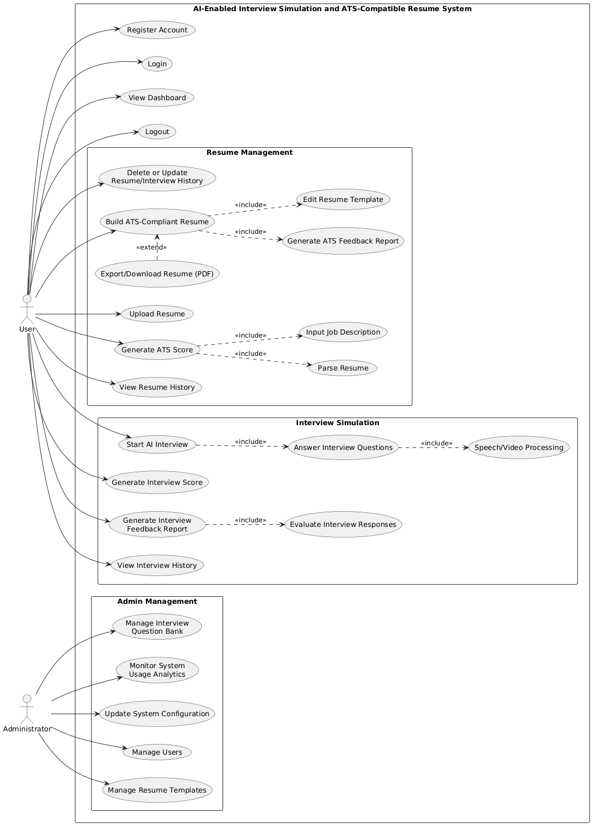
Fig-5.2.2.1 Use case diagram

SEQUENCE DIAGRAM
A sequence diagram shown in Fig-5.2.3.1 simply depicts interaction between objects in a sequential order i.e. the order in which these interactions take place. We can also use the terms event diagrams or event scenarios to refer to a sequence diagram. Sequence diagrams describe how and in what order the objects in a system function.
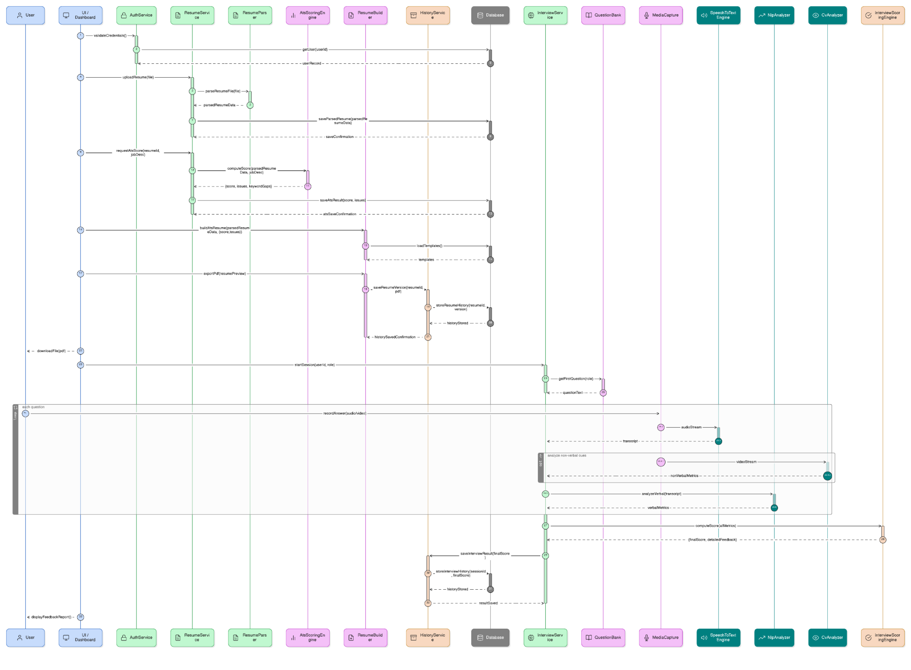

Fig-5.2.3.1 Sequence Diagram

ACTIVITY DIAGRAM
An activity diagram shown in Fig-5.2.4.1 is defined as a UML diagram that focuses on the execution and flow of the behavior of a system instead of implementation. It is also called an object-oriented flowchart. Activity diagrams consist of activities that are made up of actions that apply to behavioral modeling technology.
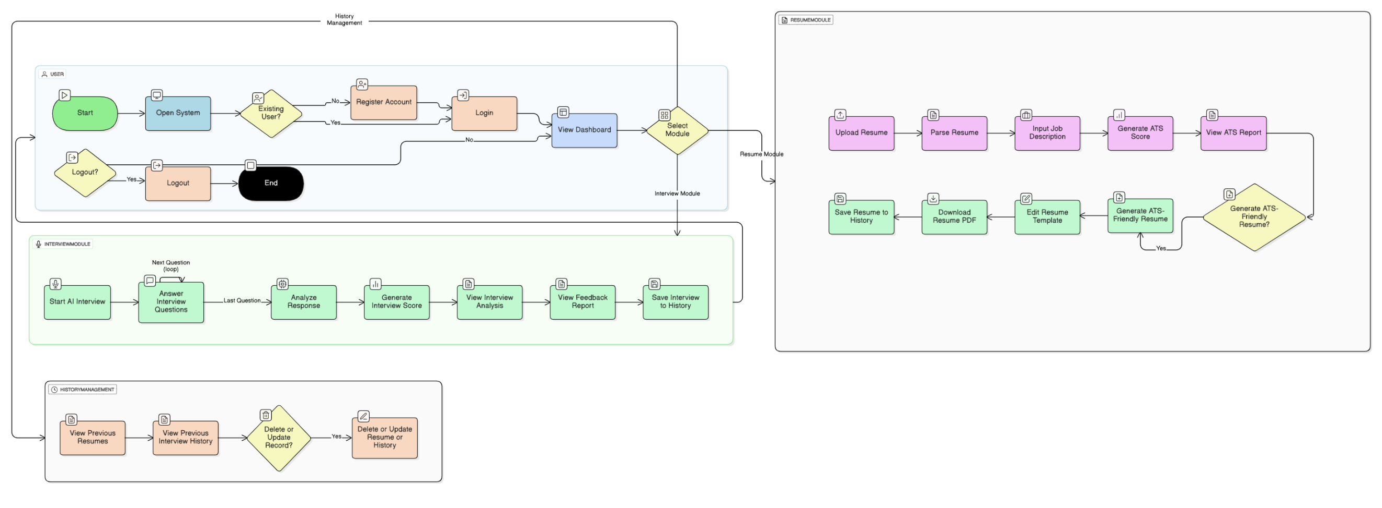
Fig-5.2.4.1 Activity Diagram

CLASS DIAGRAM
A class diagram shown in Fig-5.2.5.1 is a static structural diagram that describes the structure of a system by showing its classes, their attributes, operations (methods), and the relationships among the classes. It is one of the most important diagrams in object-oriented modeling because it gives a blueprint of how data and functions are organized inside the system.
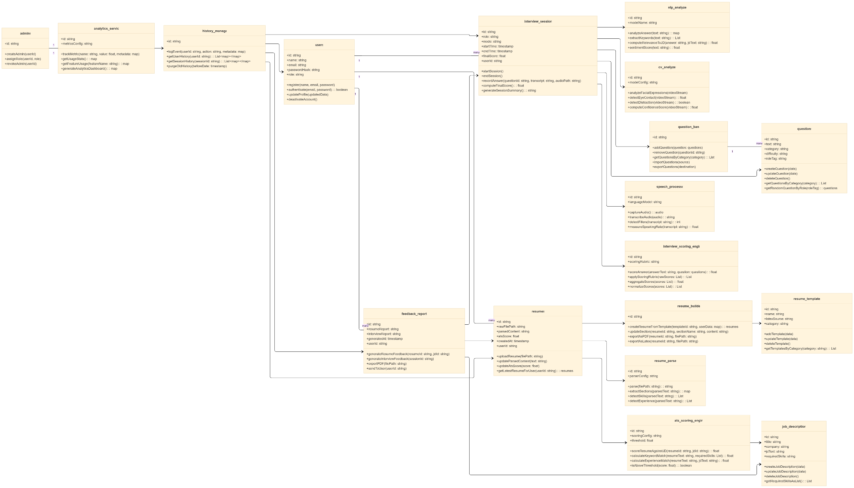
Fig-5.2.5.1 Class Diagram

SYSTEM ARCHITECTURE
The system architecture diagram shown in Fig-5.2.6.1 represents the high-level structural organization of the proposed software system. It illustrates the major components, the layers in which they are arranged, and the interactions between these components. The goal of an architecture diagram is to provide a clear overview of how the system is decomposed into subsystems and how data and control flow between them.
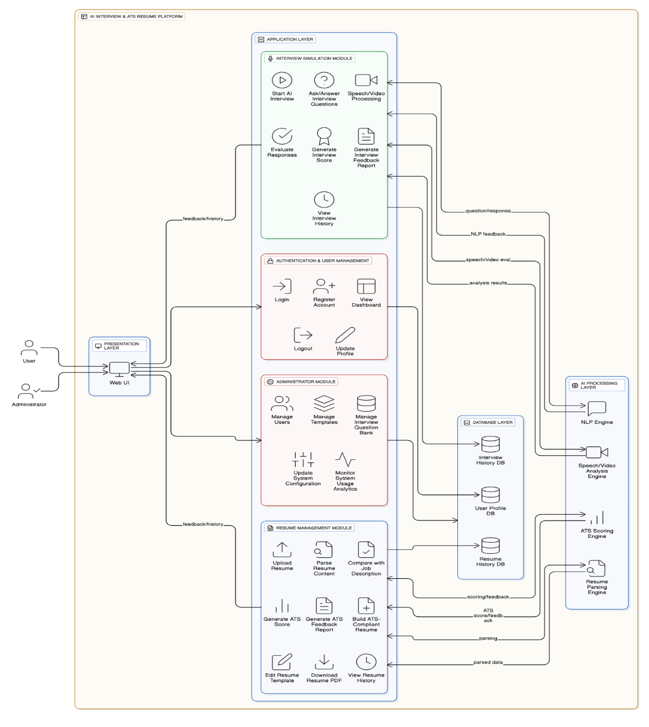
Fig-5.2.6.1 System Architecture

CONCLUSION

CONCLUSION
The project entitled “AN AI-ENABLED INTERVIEW SIMULATION AND ATS-COMPATIBLE RESUME SYSTEM FOR CAREER READINESS” has been successfully designed and partially developed with the aim of bridging the gap between candidate capability and modern recruitment requirements. The system integrates Artificial Intelligence, NLP-based mechanisms, ATS scoring algorithms, and resume optimization strategies into a consolidated platform, thereby addressing the major challenges faced by job seekers during the initial stages of the hiring process.
Through the implementation of advanced machine learning and natural language processing models, the system is capable of evaluating interview responses on parameters such as correctness, fluency, sentiment, tone, and confidence. The incorporation of Computer Vision and speech processing adds a multimodal and realistic evaluation layer to the interview assessment process. Similarly, the ATS resume scoring module analyses resume content using semantic matching, keyword density, and industry-standard ranking algorithms. This ensures that resumes are optimized for Applicant Tracking Systems used in real-world corporate environments.
The successful integration of these modules demonstrates the feasibility and effectiveness of AI-based assessment platforms in enhancing career readiness. The developed system not only provides immediate feedback and improvement suggestions but also contributes to higher resume acceptance rates and better interview preparedness. It eliminates the limitations of existing systems by offering a unified, data-driven, scalable, and highly interactive platform for skill enhancement.
In conclusion, the project proves that the use of intelligent systems can significantly support candidates in developing professional communication skills, optimizing their resume for ATS compliance, and gaining confidence for job interviews. The system has the potential to be deployed across academic institutions, professional training organizations, and recruitment services. With further enhancements in model accuracy, user experience, and dataset expansion, the system can evolve into a comprehensive career-enhancement solution capable of addressing diverse hiring scenarios.

BIBLIOGRAPHY

BIBLIOGRAPHY
[1] J. Devlin, M. Chang, K. Lee, and K. Toutanova, “BERT: Pre-training of Deep Bidirectional Transformers for Language Understanding,” Proceedings of NAACL-HLT, 2019.
[2] N. Reimers and I. Gurevych, “Sentence-BERT: Sentence Embeddings using Siamese BERT-Networks,” EMNLP, 2019.
[3] A. Robertson, S. Walker, and M. Beaulieu, “Okapi at TREC-5: Automatic Ad-hoc, Filtering, VLC and Interactive Track,” Proceedings of TREC, 1996.
[4] G. Salton and C. Buckley, “Term-Weighting Approaches in Automatic Text Retrieval,” Information Processing and Management, vol. 24, no. 5, pp. 513–523, 1988.
[5] J. Redmon, S. Divvala, R. Girshick and A. Farhadi, “You Only Look Once: Unified, Real-Time Object Detection,” IEEE Conference on Computer Vision and Pattern Recognition, 2016.
[6] S. Hochreiter and J. Schmidhuber, “Long Short-Term Memory,” Neural Computation, 1997.
[7] K. Simonyan and A. Zisserman, “Very Deep Convolutional Networks for Large-Scale Image Recognition,” arXiv preprint arXiv:1409.1556, 2014.
[8] S. Bird, E. Klein, and E. Loper, Natural Language Processing with Python, O’Reilly Media, 2009.
[9] M. Hall, E. Frank, and I. Witten, Data Mining: Practical Machine Learning Tools and Techniques, Morgan Kaufmann, 2011.
[10] M. Duan and J. Li, “Resume Parsing and Matching using NLP Techniques,” International Journal of Computer Applications, 2020.
[11] J. Chen and D. Li, “Applicant Tracking System Based Resume Screening using Keyword and Semantic Matching,” Journal of Computer Science and Information Technology, 2019.
[12] T. Mikolov, K. Chen, G. Corrado, and J. Dean, “Efficient Estimation of Word Representations in Vector Space,” arXiv preprint arXiv:1301.3781, 2013.
[13] A. K. Jain, Fundamentals of Digital Image Processing, Pearson Education, 2010.
[14] S. Russell and P. Norvig, Artificial Intelligence: A Modern Approach, 3rd ed., Prentice-Hall, 2016.
[15] Official MediaPipe Documentation, Google Developers (Online). Available: https://developers.google.com/mediapipe

